Report By: Jiadong Hong

Total: ____/20

Report: ___/20
- Exercise 1
Discuss the changes in response based on graphical observation.
We can figure out that as the b increases, the ODE tends to have smaller maximum amplitude output and the final stable value. And there are also more oscillations around the stable state as well.
The original circuit shows the result plot below
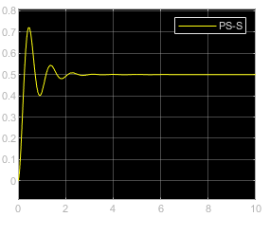
Figure 1 x(t)
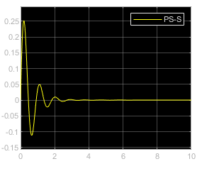
Figure 2 x'(t)
When b = 1 the result shows below,
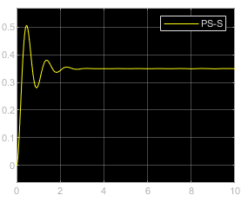
Figure 3 x(t) when b = 1
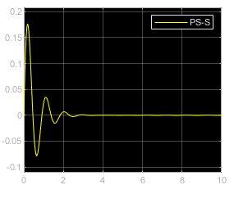
Figure 4 x'(t) when b = 1
When b = 0.4 the result shows below,
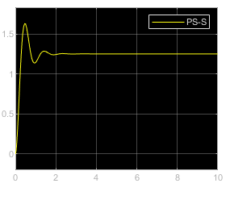
Figure 5 x(t) when b = 0.4
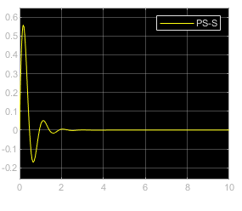
Figure 6 x'(t) when b = 0.4
- Exercise 2
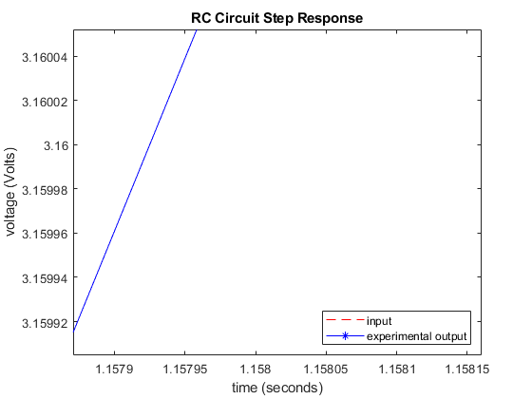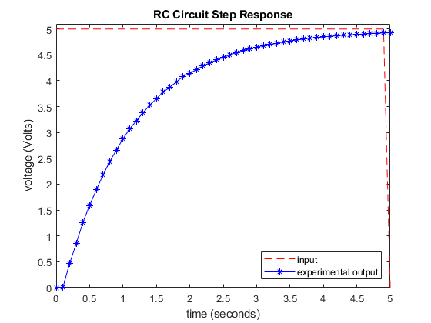
As the figures shown, we can figure out that around the voltage 3.16 which is around the 63.2% of the response, t is around 1.1579, so we take 1.16 as the approximation, the result is:
